Financial Model Instructions

**Preface**

*This document provides general instructions for how to navigate the spreadsheet (MS Excel) models used in the financial analysis of the report titled An Action Plan for Carbon Capture and Storage in California: Opportunities, Challenges and Solutions. For an overview of the structure and key assumptions of the models, please refer to Appendix C in the main report.*

*The financial results presented in the study were derived from two purpose-built spreadsheet (MS Excel) financial models: (i) Capture Facility Module (CFM) and (ii) Offsite Storage Module (OSM). The CFM is used to examine the application of new CCS to six existing CO2 sources (including transportation and storage) from an investor's perspective: FCCU operations (petroleum refinery), hydrogen production, cement production, NGCC electricity generation, CHP (combined heat and power), and ethanol production. The OSM is used to explore the construction and operation of a new, purpose-built offsite CO2 storage facility (sink and connecting trunk lines), also from an investor's perspective. The key output variables for both financial models are net present value (NPV) and internal rate of return (IRR). The two models are not linked, but indeed related; for example, contract prices from the OSM could be used as cost inputs for the CFM.*

1. General Configurations

It is very likely that the first time the Financial model is opened, two messages will appear. The first message (Figure 1) indicates that the file came from the internet. Click "Enable Editing", otherwise all results displayed will be static, i.e no new calculations or change of assumptions will be enabled.

Figure 1 – Warning message about the origin of the file



The following message (Figure 2) warns the user that the file contains Macros (i.e., built-in functions that perform some automatic functions) and that those have been disabled. This is a default security measure within the Excel environment. In this Financial Model, the Macros update the sensitivity tables automatically, so it is important that the user enables them by clicking "Enable Content".

Figure 2 – Warning message about Macros



Finally, before using the model, the user must check that formulas are calculated automatically and that circularity is allowed. Regarding the latter, circularity means that some cells' inputs are affected by that cell's very output, forming a loop, which is common in Financial Models. To make sure the spreadsheet is configured correctly, for **Windows/PC**, go to the menu "File", and then select "Options" on the left column. A new window will pop-up, then choose the category "Formulas" on the left side. Set the configurations as displayed in Figure 3a. For **Mac/OS**, go the menu “Excel”, select “Preferences” and in the subsequent menu, select “Calculation.” Set the configurations as displayed in Figure 3b.

Figure 3a – Excel Options for Windows/PC

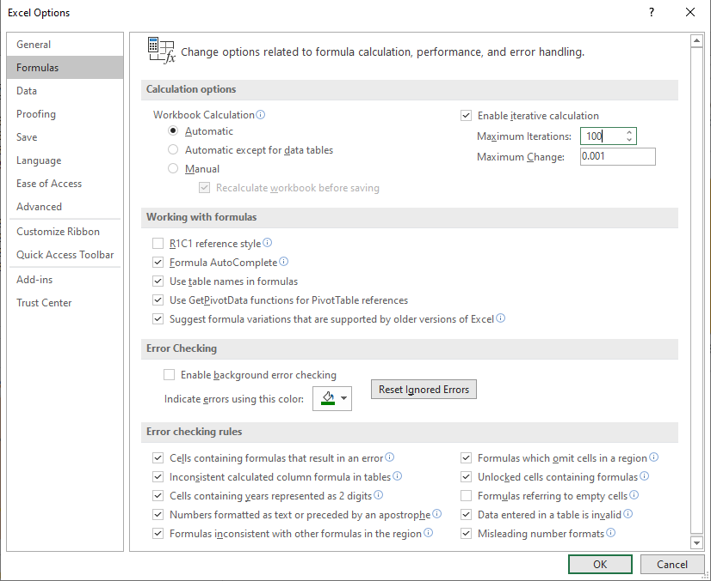

Figure 3b – Excel Options for Mac/OS

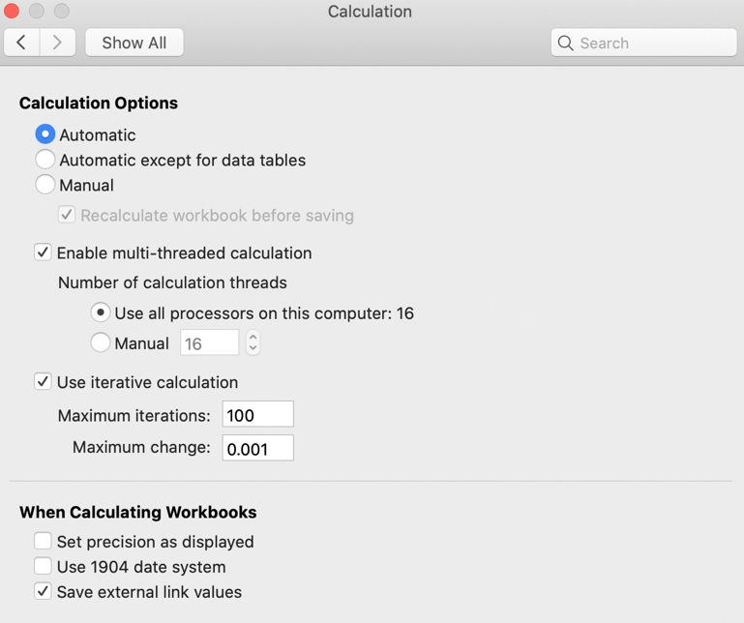

1. Capture Facility Model

This financial model presents a number of tabs that perform different calculations, forecasting the cash-flows of an investment in a new capturing facility, considering the incentives and benefits from several currently available incentives.

The design allows for simple configuration and modifications to be done without having to retype values. Standard runs will require only that a given application is selected (on cell F9 of **Control** tab, or cell B4 of **Summary** tab), and the results will be shown (e.g., estimated IRR will be shown on cell P6 in the tab **Control** tab). Obviously, the main idea of having such a tool is to allow estimations in a variety of scenarios, and so the next sections will discuss how to change the main settings of the model, in every tab.

Moreover, a color code visualizes the relevance/type of cells (main selectors and assumptions are filled in different **cell** colors), and the origin of any given information (indicated by the **text** color) – Table 1 provides a legend of the color coding.

**Table 1: Color code used in the financial model of the capturing facility**

|  |  |
| --- | --- |
| Pink Fill | Main application selector |
| Green Fill | Main operational assumptions |
| Yellow Fill | Toggle boxes |
| Grey Fill | Assumptions from Hub model (or NETL Models) |
| Black Text | Calculated values |
| Blue Text | Hardwired values |
| Green Text | Values linked from other tabs |

* 1. Cover Tab

This tab simply displays the title, authors, version, and other general information about the Financial Model. Here, the user must only certify that the version being used presents the word "Final" and Version 17.0 on the top left corner.

* 1. Summary Tab

Users looking for higher-level information will find this tab most useful. No calculation is performed here, but the most relevant results are displayed in a consolidated fashion that can be exported to presentations or other documents. For that reason, the information displayed here doesn't follow the color code showed in Table 1. For example, the red, blue, and green colors on the two tables on the left merely distinguish the optimistic, base, and conservative cases.

The only field adjustable by the user is on cell B4, where the application is selected. Once this configuration is set, all the other tables will be updated automatically (if not, check if the workbook calculation is set as automatic, as explained in Section 1).

The two tables on the left of the tab (columns B-F and H-L) display essentially the same information but in different formats. The table on the left displays the change on the IRR given variations on various assumptions. For example, cell D6 shows the IRR for an LCFS value of $150/ton (optimistic case); in cell E6, for an LCFS value of $100/ton (base case); and on cell F6, for an LCFS value of $50/ton (conservative case). Cells J6, K6 and L6 display the same information, however, using a graphical notation indicated in the key below according to the variation from the base case.

**Table 2: Graphical notation of IRR variations**



The three tables in columns S-X illustrate the quantity of the emissions captured would be in-the-money, that is, would be economically attractive (according to the threshold IRR defined on cell U3) to be captured and sequestered, for a given combination of value and term of the existing incentive programs (LCFS, Cap-and-trade, and both combined). It is important to note that all cases include the base case assumptions for the 45Q (12 years of duration and $40/ton).

The chart on the extreme right is static and simply displays the attractivness of every application. It helps to understand which applications would be in-the-money for a given emissions quantity. For example, for an LCFS value of $100/ton for 15 years, 17.93MT would be in-the-money, which corresponds to Ethanol (0.43MT), H2 (11.20MT), and FCC (6.30MT).

Finally, the tables below row 35 depict the main assumptions used in the financial model grouped into categories. For the sake of simplicity, not all assumptions are shown here, and those tables are only for display – modification of the values here will not change the inputs/outputs model. To modify the assumptions used in the model, see the following section **Contol** tab.

* 1. Control Tab

Here is the model's “gear box” where several assumptions can be changed, and all main results are displayed.

The tab is organized in three main groups. On the left, **all** the assumptions used in the financial model are presented; even those that come from different tabs are shown here (in green text), forming a central panel where the user can quickly check all the critical details. In the center of the spreadsheet, the IRR (cell P6) and NPV (cell P7, with the discount rate of cell O7) are presented. Below these values are sensitivity tables for IRR given changes to selected input variables. Finally, there are the Incentive Tables on the right, analyzing specifically the impact of various combinations of term and values of the incentives available for CCS.

As suggested by the color code, all **blue** values are hardwired and can be modified by the user directly on this tab. Values in **green** come from different tabs, and it would be wise to change them in their original tabs to preserve the links. Values in **black** are the result of calculations and should not be modified to preserve the formulas, except the sensitivity tables, where any changes in the black values will be overwritten when those tables are updated. The more commonly changed configurations are presented in a toggle box format in **yellow**, so instead of typing, the user can more conveniently select from a list of possible values.

The main *toggle box* is the application selector on cell F9, which will cause a refresh of the whole financial model once it is modified. Note that the “case selector” in **Summary** tab is independent of the one in this **Control** tab; as mentioned previously, modifications on the summary tab will not affect the model.

Another *toggle box* is on cell located in cell F46, where the user can choose the scenario regarding the incentives that will be considered in the modeling. The table of cells L11-O18 (depicted below) indicates which incentives are considered in each scenario. The choice of a given scenario will automatically adjust the value of cells F47, F56 and F65, to turn on/off Cap-and-trade, 45Q, LCFS incentives, respectively,

**Table 3: Scenarios of incentives**

|  |  |  |  |
| --- | --- | --- | --- |
| Scenarios | **45Q** | **LCFS** | **Cap-and-Trade** |
| **Scenario of Incentives** | |  |  |
| **0** | Yes | No | No |
| **1** | Yes | Yes | No |
| **2** | Yes | Yes | Yes |
| **3** | No | Yes | No |
| **4** | No | No | Yes |
| **5** | Yes | No | Yes |

Among the LCFS assumptions (cells F65-F73), there is the option to choose which scenario of LCFS prices, that is, the LCFS credits' value corresponding to a ton of CO2 abated. This can be done via cell F66, where the user will see the option "Std" and numbers from 1 to 10. The Standard scenario (identified as "Std") will use a constant LCFS price over time, defined on cell F72, only adjusted by the inflation rate (cell F6). The scenarios with numbers (from 1 to 10) correspond to the various price curves obtained from a CARB study about Zero Emissions Vehicles' impact and different carbon intensity goals. Those curves can be found in the **LCFS from Carb** tab, where each scenario is identified on cells A16-A25.

There is also a toggle box to turn on/off the consideration of a co-located storage (cell F32). With co-located storage, besides the transportation and sequestration costs on cell F24, the model will consider the need for a Financial Responsibility Trust Fund, with the characteristics defined on cells F33-F37.

The sensitivity tables on the center of the spreadsheet are updated by clicking on arrow button *Run sensitivities*. The Incentive Tables, on the right side, are updated by clicking on the arrow *Update Incentive Tables*. These functions may take a few minutes to run, and the whole model will be unavailable during that period. The state of several assumptions will be changed while the functions are running, but they will be restored to their initial condition after the run is concluded. The user can also change the values used in any of the Sensitivity or Incentive Tables scenarios, basically changing the values in **blue** in the first row or the first column (for Incentive Tables), and then click on the respective button to provoke the refresh of those tables.

Finally, some assumptions have a percentage displayed besides the value, on column G (e.g., Capture Facility Capex as a value on cell G31). Those percentages allow the user to increase/decrease that assumption's value without overwriting the original value. For example, to simulate a Capture Facility Capex 10% higher, the user only has to type 110% on the cell G22.

* 1. Financials Tab

If the **Control** tab is the “gearbox”, the **Financials** tab is the model’s engine. Here the financial statements are calculated, including the income statement, balance sheet, and cash-flow statement. This tab will be rather familiar for users with some finance experience, with statements following the typical structure.

Users less experienced may take advantage of the two graphics displayed at the end of the tab. The first is placed at rows 92-110 shows, in orange color, the cash-flow paid to equity, that is, shareholders that retain ownership over the ProjectCo; and, in blue color, the cash-flow that is paid to debt holders, typically banks and other financiers.

As mentioned in the preface, this model was constructed looking from the investor's perspective, so the IRR and NPV are calculated over the cash-flow to equity, and can be seen in this tab too on cells H86 and H87, respectively. The discount rate used to calculated the NPV comes from cell O7 from the **Control** tab. The amount of available cash and income distributed to shareholders can also be adjusted on cells F89 and F90 of the tab control, respectively. Another assumption that directly affects the IRR and NPV of the investment is the exit multiple of the ProjectCo. After the project's lifetime, there can be some value on the company's books, as residual tax benefits and properties. The model assumes that 80% of this remaining value can be recovered (i.e., selling to another investor or liquidating the remaining asset/PPE), equivalent to a 0.8x multiple. This multiple can be adjusted on cell F91 of the Control tab and will directly determine the cash-flow to equity in the last year of the ProjectCo's life.

The second graphic, displayed at rows 121-147, compares the cash-flow to equity of the different applications included in this financial model (e.g., H2, Cement, FCC, etc.), each of them considering the same general assumptions, as the value of the incentives, duration, construction period, among others. However, this graphic is not refreshed automatically, avoiding excess of processing load. So, any time general assumptions are modified, the user has to click on the button "Update Graphic" to have a new snapshot of the cash-flow to equity in those different applications.

* 1. Schedules Tab

Here all the auxiliary schedules are calculated, and specific details of the project can be found. For example, in this tab, the depreciation curve, debt service, Capex, and Opex are estimated. Typically this tab will be helpful to answer some more specific questions (e.g., what is the main operating expense in a given year?) or observe in detail the impact of more general assumptions (e.g., what does happen with the Capex curve when the construction is delayed one year?).

The very few values presented in blue indicate that only some adjustments are possible in this tab: the MACRS depreciation (row 45), which is an accelerated depreciation allowed by IRS for some specific infrastructure projects, and working capital assumptions, defined as a number of days of accounts receivable (G63) and payable (G66 and G67).

It is relevant to note that working capital assumptions do not affect the minimum cash requirement - minimum amount of cash the ProjectCo has to keep to fulfill its financial commitments (e.g., taxes, labor, suppliers). The minimum cash requirement is defined as days of Opex on cell F88 of Control tab. For example, 180 days of Opex means the ProjectCo has to keep roughly 50% (180 days/ 365 days in a year) of the annual Opex in its cash balance. The minimum cash requirement affects how much cash can be distributed to the shareholders, as shown in the calculations on rows 149-158.

* 1. Operational Tab

This tab is the central source of the assumptions regarding the construction and operation of a capturing facility in each of the studied applications of this report. They are the same assumptions used in the analyses made on the Opportunities Chapter of the report, however considering a standard size of a capturing facility for each application.

As can be noticed, all values here are in blue, indicating that the user can adjust those assumptions as necessary, and the model will utilize those to recalculate the proper Capex and Opex of the project.

In terms of eligibility to the incentives, the percentages exhibited on columns P and Q are conditioned by the scenario configured on cell F46 of **Control** tab. Thus, if, for example, even if Cement's project displays 100% eligibility to Cap-and-trade in this tab, and Scenario 1 is configured on the cell F46 of the **Control** tab, only 45Q and LCFS (which is 0% for Cement) will be considered as sources of benefits.

* 1. Tab LCFS from CARB

This tab presents 10 LCFS price scenarios that were obtained from CARB in their study of the impact of the increasing penetration of Zero Emissions Vehicles (ZEV) for different carbon intensity goals. Because this spreadsheet was directly incorporated in the model, it doesn't follow the standard formatting and color code of the other tabs; all values are hardwired.

The user can select any of those scenarios when estimating a project's returns directly the on cell F66 of **Control** tab. Moreover, it is also possible to overwrite any of the given values to introduce an entirely new LCFS price scenario without modifying the model's mechanics.

1. Offsite Storage Module

This financial model examines the investment in CO2 storage facility and transportation infrastructure, having as reference the models from NETL[1],[2]. The structure, formatting, and color code of this model are very similar to the CFM, so the same recommendations apply here.

* 1. Cover Tab

This tab displays the title, authors, version, and other general information about the Financial Model. Here, the user must only certify that the version being used presents the word "Final" and Version 3.0 on the top left corner.

* 1. Control Tab

This tab contains all the main assumptions and results of the model and often will be the only tab used by the user. The information is divided into two main groups. On the left, all the financial model inputs are shown, and even the inputs originated in other tabs are displayed here, composing one central repository of all the relevant data about the project. On the right, we have all the results: including the IRR (cell P7) and the NPV (cell P7, discounted at a rate defined on cell O7), both calculated over the cash-flow to equity. Still on the right side, we have Sensitivity Tables starting on row 11.

Those Sensitivity Tables show the IRR for a combination of values of the main assumptions. The values corresponding to the base case of each assumption are highlighted with a **blue** shading. To reduce the processing load, by default, those tables are only updated if the user presses the key F9 on the keyboard. This setting can be changed, putting the workbook calculation in automatic in the "Excel Options" window (see item 1 of this manual). The user can also change the values used in each scenario of the sensitivity tables, modifying the **blue** values in the first row/column of those tables.

Most of the assumptions can be changed directly in this tab, as they are displayed in **blue** text, indicating that they were hardwired here. However, a few assumptions, mainly related to the Capex of the facility, come from the tab Capex, as we will discuss later.

Unlike the CFM, this model does not consider any Carbon incentive (e.g., 45Q, Cap-and-trade, or LCFS). Instead, all revenues come from commercial contracts to transport and sequester the CO2. The model allows the user to simulate two contracts, defined on cells F50-F56 and F59-F65. There are toggle boxes on cells F50 and F65 to turn those contracts on and off.

Again, the user can adjust the values of some operational assumptions using the Factor cells (column G), instead of rewriting the original values. For example, to simulate a Storage Capex 10% higher, the user only has to type 110% on the cell G31.

Finally, in this model, the user does not have the option to turn off the Financial Responsibility Trust Fund, as it was allowed in the CFM, because the storage facility will always have this trust fund associated with the investment.

* 1. Financials and Schedules Tabs

Those tabs are very similar to the tabs with the same name in the CFM; see items 2.4 and 2.5 for an explanation of the contents and possible configurations made here.

* 1. Capex Tab

This is essentially the tab where all the main Capex elements of the storage facility and transportation infrastructure are presented. The spreasheet is divided in those two groups: Transportation and Storage, and the items listed are the same of those found in the NETL models1,2.

Each Capex item has a disbursement curve (rows 9-16 and 33-36), indicating the percentage of the investment that is incurred every year, and the effective amount spent in those years (rows 21-28 and 39-42), which is the multiplication of that percentage by the total cost of said Capex item. Moreover, because the NETL models' results are in dollar values of past years, 2011 for the transportation items and 2008 for the storage items, these values are brought to 2020 values multiplying by the accumulated inflation in the period (cells F21 and F39).

The best way of adjusting values in this tab is by inserting the total expected costs of each Capex item on cells E21-E28 and E39-E42, the accumulated inflation (which can be 1, if the values inserted are already in current dollars), and the expected disbursement curves on rows 9-16 and 33-36.

1. National Energy Technology Laboratory (2017). FE/NETL CO2 Saline Storage Cost Model. U.S. Department of Energy. Last Update: set YYYY (Version 3) https://www.netl.doe.gov/research/energy-analysis/search-publications/vuedetails?id=2403
2. National Energy Technology Laboratory (2018). FE/NETL CO2 Transport Cost Model. U.S. Department of Energy. Last Update: mai YYYY (Version 2b) https://www.netl.doe.gov/research/energy-analysis/search-publications/vuedetails?id=543.